|  |
| --- |
| МИНОБРНАУКИ РОССИИ |
| Федеральное государственное бюджетное образовательное учреждение высшего образования **«МИРЭА − Российский технологический университет»**  **РТУ МИРЭА** |

**Институт информационных технологий (ИИТ)**

**Кафедра прикладной математики (ПМ)**

**ОТЧЕТ ПО ПРАКТИЧЕСКОЙ РАБОТЕ**

по дисциплине «Модели и методы предиктивной аналитики»

**Практическое занятие № 1**

|  |  |  |  |
| --- | --- | --- | --- |
| Студент группы ИНБО-01-17 | *ИМБО-02-22, Ким Кирилл Сергеевич* | (подпись) | |
| Преподаватель | *Крынецкий Борис Алексеевич, преподаватель* | (подпись) | |
| Отчет представлен | «___»________202__г. | |  | |

Москва 2025 г.

СОДЕРЖАНИЕ

ПРАКТИЧЕСКАЯ РАБОТА 1 3

Введение 3

Шаги выполнения 3

Результат работы: 19

Вывод: 19

Список использованных источников и литературы: 19

ПРАКТИЧЕСКАЯ РАБОТА 1

Введение

**Цель**

Сформировать три отдельных набора данных, представляющих собой временные ряды, многомерные данные и наборы текста из открытых источников. Приоритетным инструментом для сбора данных является использование API.

Шаги выполнения

1. Найти подходящий API для каждого типа данных. Зарегистрироваться и получить ключи доступа к API.

Временной ряд:

<https://open-meteo.com/en/docs>

Многомерные данные:

<https://pokeapi.co/>

Наборы тексты:

<https://newsapi.org/>

1. Разработка скриптов для парсинга.

Листинг 1 – для временного ряда

|  |
| --- |
| import requests  import pandas as pd  import numpy as np  import requests_cache  from retry_requests import retry  import logging  from typing import Optional, List, Dict, Tuple  from datetime import datetime, timedelta  import json  from urllib.parse import urlparse, parse_qs  import re  import os  logging.basicConfig(  level=logging.INFO,  format='%(asctime)s - %(levelname)s - %(message)s',  handlers=[  logging.FileHandler('storm_warning_system.log', encoding='utf-8'),  logging.StreamHandler()  ]  )  logger = logging.getLogger(__name__)  cache_session = requests_cache.CachedSession('.cache', expire_after=86400)  retry_session = retry(cache_session, retries=5, backoff_factor=0.3)  def parse_parameters_from_url(url: str) -> Tuple[Optional[float], Optional[float], List[str], Optional[str]]:  try:  parsed = urlparse(url)  query = parse_qs(parsed.query)  latitude = float(query.get('latitude', [None])[0]) if query.get('latitude') else None  longitude = float(query.get('longitude', [None])[0]) if query.get('longitude') else None  hourly_params = []  if 'hourly' in query:  hourly_value = query['hourly'][0]  hourly_params = hourly_value.split(',') if hourly_value else []  timezone = query.get('timezone', [None])[0]  if timezone:  timezone = requests.utils.unquote(timezone)  logger.info(f"Извлечено из URL: lat={latitude}, lon={longitude}, tz={timezone}")  logger.info(f"Параметры hourly: {hourly_params}")  return latitude, longitude, hourly_params, timezone  except Exception as e:  logger.error(f"Ошибка при парсинге URL: {e}")  return None, None, [], None  def get_historical_weather(  latitude: float,  longitude: float,  start_date: str,  end_date: str,  hourly_params: Optional[List[str]] = None,  timezone: str = "Europe/Moscow"  ) -> Optional[pd.DataFrame]:  url = "https://archive-api.open-meteo.com/v1/archive"  params_from_url = [  "temperature_2m", "wind_speed_10m", "wind_speed_80m", "wind_speed_120m",  "wind_speed_180m", "wind_direction_10m", "wind_direction_80m",  "wind_direction_180m", "wind_gusts_10m", "wind_direction_120m",  "precipitation", "relative_humidity_2m", "pressure_msl", "weather_code", "snowfall",  "snow_depth", "cloud_cover", "cloud_cover_low", "cloud_cover_mid",  "cloud_cover_high", "rain", "showers", "vapour_pressure_deficit",  "apparent_temperature", "dew_point_2m", "et0_fao_evapotranspiration"  ]  final_params = hourly_params if hourly_params else params_from_url  params = {  "latitude": latitude,  "longitude": longitude,  "start_date": start_date,  "end_date": end_date,  "hourly": ",".join(final_params),  "timezone": timezone  }  try:  logger.info(f"Запрос к API: {url}")  logger.info(f"Параметры: {params}")  response = retry_session.get(url, params=params, timeout=60)  response.raise_for_status()  data = response.json()  if data.get("error"):  logger.error(f"API вернул ошибку: {data['reason']}")  return None  if "hourly" not in data or not data["hourly"]:  logger.warning("Нет данных в ключе 'hourly'")  return None  df = pd.DataFrame(data["hourly"])  df["time"] = pd.to_datetime(df["time"])  df.set_index("time", inplace=True)  for col in df.columns:  df[col] = pd.to_numeric(df[col], errors='coerce')  logger.info(f"Успешно загружено: {len(df)} записей, {len(df.columns)} переменных")  logger.info(f"Столбцы: {list(df.columns)}")  return df  except requests.exceptions.HTTPError as e:  logger.error(f"HTTP ошибка: {e}")  if hasattr(e, 'response') and e.response is not None:  logger.error(f"Response content: {e.response.text}")  return None  except requests.exceptions.Timeout:  logger.error("Таймаут запроса к API")  return None  except requests.exceptions.RequestException as e:  logger.error(f"Ошибка соединения: {e}")  return None  except Exception as e:  logger.error(f"Неизвестная ошибка: {e}")  return None  def create_storm_labels(  df: pd.DataFrame,  wind_threshold: float = 15.0,  gust_threshold: float = 25.0,  precip_threshold: float = 7.0,  pressure_drop_window: int = 3,  pressure_drop_threshold: float = 4.0,  include_weather_code: bool = True  ) -> pd.DataFrame:  if df is None or df.empty:  return df  df = df.copy()  storm_conditions = pd.Series(False, index=df.index)  # 1. Сильный ветер на разных высотах  wind_columns = [col for col in df.columns if col.startswith('wind_speed_')]  for wind_col in wind_columns:  storm_conditions |= (df[wind_col] >= wind_threshold)  # 2. Порывы ветра  if "wind_gusts_10m" in df.columns:  storm_conditions |= (df["wind_gusts_10m"] >= gust_threshold)  # 3. Сильные осадки  precip_columns = ["precipitation", "rain", "showers"]  for precip_col in precip_columns:  if precip_col in df.columns:  storm_conditions |= (df[precip_col] >= precip_threshold)  # 4. Быстрое падение давления (штормовой признак)  pressure_col = None  for col in ["pressure_msl", "surface_pressure"]:  if col in df.columns:  pressure_col = col  break  if pressure_col:  delta_p = df[pressure_col].diff(periods=pressure_drop_window)  rapid_drop = delta_p < -pressure_drop_threshold  storm_conditions |= rapid_drop.fillna(False)  # 5. Опасные погодные коды  if include_weather_code and "weather_code" in df.columns:  storm_codes = [65, 75, 82, 85, 86, 95, 96, 99]  storm_conditions |= df["weather_code"].isin(storm_codes)  # 6. Высокая облачность (признак неустойчивости)  cloud_columns = [col for col in df.columns if col.startswith('cloud_cover')]  for cloud_col in cloud_columns:  if cloud_col in df.columns:  storm_conditions |= (df[cloud_col] >= 80) # Облачность > 80%  df["is_storm"] = storm_conditions.astype(int)  storm_count = df["is_storm"].sum()  logger.info(f"Создано меток шторма: {storm_count} из {len(df)} ({storm_count / len(df) * 100:.2f}%)")  return df  def save_results(df: pd.DataFrame, filename: str, metadata: Optional[Dict] = None):  try:  os.makedirs('data', exist_ok=True)  filepath = f"data/{filename}"  df.to_csv(filepath, encoding='utf-8')  logger.info(f"Данные сохранены: {filepath}")  if metadata:  metapath = filepath.replace('.csv', '_metadata.json')  with open(metapath, 'w', encoding='utf-8') as f:  json.dump(metadata, f, indent=2, ensure_ascii=False)  logger.info(f"Метаданные сохранены: {metapath}")  except Exception as e:  logger.error(f"Ошибка при сохранении: {e}")  def main():  source_url = (  "https://open-meteo.com/en/docs?hourly=temperature_2m,wind_speed_10m,wind_speed_80m,"  "wind_speed_120m,wind_speed_180m,wind_direction_10m,wind_direction_80m,wind_direction_180m,"  "wind_gusts_10m,wind_direction_120m,precipitation,relative_humidity_2m,pressure_msl,weather_code,"  "snowfall,snow_depth,cloud_cover,cloud_cover_low,cloud_cover_mid,cloud_cover_high,rain,"  "showers,vapour_pressure_deficit,apparent_temperature,dew_point_2m,et0_fao_evapotranspiration&timezone=Europe%2FMoscow&"  "latitude=55.7522&longitude=37.6156"  )  latitude, longitude, hourly_params, timezone = parse_parameters_from_url(source_url)  if latitude is None or longitude is None:  latitude, longitude = 55.7522, 37.6156  logger.warning("Используются координаты по умолчанию: Москва")  if not timezone:  timezone = "Europe/Moscow"  logger.warning("Используется временная зона по умолчанию: Europe/Moscow")  start_date = '2022-01-01'  end_date = '2025-09-18'  logger.info("Запуск парсера погодных данных Open-Meteo")  logger.info(f"Координаты: {latitude}, {longitude} | Таймзона: {timezone}")  logger.info(f"Период: {start_date} — {end_date}")  logger.info(f"Запрашиваемые параметры: {hourly_params}")  df = get_historical_weather(  latitude=latitude,  longitude=longitude,  start_date=start_date,  end_date=end_date,  hourly_params=hourly_params,  timezone=timezone  )  if df is None or df.empty:  logger.error("Не удалось получить данные или данные пустые.")  return  labeled_df = create_storm_labels(  df,  wind_threshold=15,  gust_threshold=25,  precip_threshold=7,  pressure_drop_window=3,  pressure_drop_threshold=4.0,  include_weather_code=True  )  save_results(  labeled_df,  "storm_data.csv",  metadata={  "source_url": source_url,  "location": {"lat": latitude, "lon": longitude},  "timezone": timezone,  "date_range": {"start": start_date, "end": end_date},  "hourly_params": hourly_params,  "storm_criteria": {  "wind_speed_* >= km/h": 15,  "wind_gusts_10m >= km/h": 25,  "precipitation/rain/showers >= mm/h": 7,  "pressure_drop >= hPa/3h": 4.0,  "storm_weather_codes": [65, 75, 82, 85, 86, 95, 96, 99],  "cloud_cover >= %": 80  },  "generated_at": datetime.now().isoformat(),  "total_rows": len(labeled_df),  "storm_events_count": int(labeled_df["is_storm"].sum()),  "columns_list": list(labeled_df.columns)  }  )  logger.info(f"Общее количество записей: {len(labeled_df)}")  logger.info(f"Количество штормовых событий: {labeled_df['is_storm'].sum()}")  logger.info(f"Доля штормовых событий: {labeled_df['is_storm'].mean() * 100:.2f}%")  logger.info(f"Период данных: от {labeled_df.index.min()} до {labeled_df.index.max()}")  logger.info("Готово: данные успешно получены и сохранены")  if __name__ == "__main__":  main() |

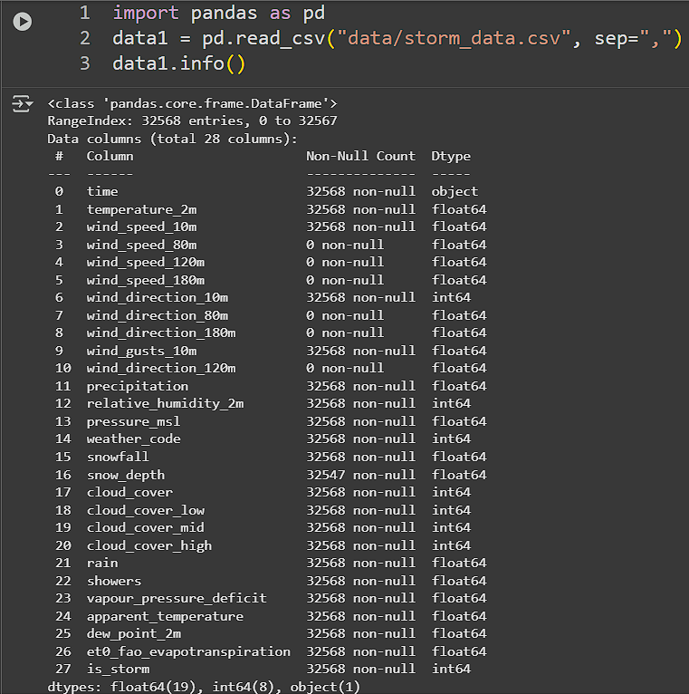

**Рисунок 1 – Временной ряд**

Листинг 2 – для многомерных данных

|  |
| --- |
| import requests  import time  import csv  from typing import List, Dict, Any  BASE_URL = "https://pokeapi.co/api/v2"  def get_json(url: str) -> Dict[str, Any]:  try:  resp = requests.get(url, timeout=10)  resp.raise_for_status()  return resp.json()  except requests.exceptions.RequestException as e:  print(f"Ошибка при запросе {url}: {e}")  return {}  def get_pokemon_list(limit: int = 100, offset: int = 0) -> List[Dict[str, Any]]:  url = f"{BASE_URL}/pokemon?limit={limit}&offset={offset}"  data = get_json(url)  return data.get("results", [])  def get_encounter_locations(pokemon_url: str) -> str:  location_url = pokemon_url + "/encounters"  try:  locations = get_json(location_url)  if locations:  names = {  loc.get("location_area", {}).get("name", "unknown")  for loc in locations if loc.get("location_area")  }  return ", ".join(sorted(names)[:10])  return ""  except:  return ""  def get_evolution_chain(evolution_chain_url: str) -> str:  if not evolution_chain_url:  return ""  data = get_json(evolution_chain_url)  if not data:  return ""  def parse_chain(chain):  name = chain.get("species", {}).get("name", "")  evolves_to = chain.get("evolves_to", [])  if not evolves_to:  return name  next_names = [parse_chain(evo) for evo in evolves_to]  return " -> ".join([name] + next_names)  return parse_chain(data.get("chain", {}))  def get_pokemon_details(pokemon_url: str) -> Dict[str, Any]:  data = get_json(pokemon_url)  if not data:  return {}  species_url = data.get("species", {}).get("url")  species_data = get_json(species_url) if species_url else {}  stats = {}  for s in data.get("stats", []):  stat_name = s["stat"]["name"]  stats[stat_name] = s["base_stat"]  types = [t["type"]["name"] for t in data.get("types", [])]  type_1 = types[0] if len(types) > 0 else ""  type_2 = types[1] if len(types) > 1 else ""  # Способности  abilities = []  hidden_ability = ""  for ab in data.get("abilities", []):  if ab.get("is_hidden"):  hidden_ability = ab["ability"]["name"]  else:  abilities.append(ab["ability"]["name"])  ability_1 = abilities[0] if len(abilities) > 0 else ""  ability_2 = abilities[1] if len(abilities) > 1 else ""  moves = [m["move"]["name"] for m in data.get("moves", [])[:5]]  while len(moves) < 5:  moves.append("")  return {  "id": data.get("id"),  "name": data.get("name"),  "base_experience": data.get("base_experience"),  "height": data.get("height"),  "weight": data.get("weight"),  "order": data.get("order"),  # Типы  "type_1": type_1,  "type_2": type_2,  # Способности  "ability_1": ability_1,  "ability_2": ability_2,  "hidden_ability": hidden_ability,  "hp": stats.get("hp", 0),  "attack": stats.get("attack", 0),  "defense": stats.get("defense", 0),  "special_attack": stats.get("special-attack", 0),  "special_defense": stats.get("special-defense", 0),  "speed": stats.get("speed", 0),  # Движения (по столбцам)  "move_1": moves[0],  "move_2": moves[1],  "move_3": moves[2],  "move_4": moves[3],  "move_5": moves[4],  # Спрайты  "sprite_default": data.get("sprites", {}).get("front_default"),  "sprite_shiny": data.get("sprites", {}).get("front_shiny"),  "sprite_artwork": data.get("sprites", {}).get("other", {}).get("official-artwork", {}).get("front_default"),  # Species  "color": species_data.get("color", {}).get("name"),  "generation": species_data.get("generation", {}).get("name"),  "habitat": species_data.get("habitat", {}).get("name") if species_data.get("habitat") else "",  "shape": species_data.get("shape", {}).get("name"),  "is_legendary": 1 if species_data.get("is_legendary", False) else 0,  "is_mythical": 1 if species_data.get("is_mythical", False) else 0,  "capture_rate": species_data.get("capture_rate"),  "base_happiness": species_data.get("base_happiness"),  "growth_rate": species_data.get("growth_rate", {}).get("name"),  "egg_groups": ", ".join([eg["name"] for eg in species_data.get("egg_groups", [])]),  # Эволюция  "evolution_chain": get_evolution_chain(species_data.get("evolution_chain", {}).get("url")),  # Локации  "encounter_locations": get_encounter_locations(pokemon_url),  }  def parse_all_pokemon(total_limit: int = 100, pause_sec: float = 0.1) -> List[Dict[str, Any]]:  all_pokemon = []  offset = 0  batch_size = 100  print(f"Начинаем сбор данных о {total_limit} покемонах...")  while len(all_pokemon) < total_limit:  remaining = total_limit - len(all_pokemon)  current_batch = min(batch_size, remaining)  batch = get_pokemon_list(limit=current_batch, offset=offset)  if not batch:  break  for pokemon in batch:  details = get_pokemon_details(pokemon["url"])  if details:  all_pokemon.append(details)  print(f"{details['id']:>3} | {details['name']:<12} | {details['type_1']}/{details['type_2']}")  time.sleep(pause_sec)  offset += len(batch)  print(f"Готово: {len(all_pokemon)} покемонов обработано.")  return all_pokemon  def save_to_csv(data: List[Dict[str, Any]], filename: str = "pokemon_data.csv"):  if not data:  print("Нет данных для сохранения.")  return  fieldnames = [  "id", "name", "base_experience", "height", "weight", "order",  "type_1", "type_2",  "hp", "attack", "defense", "special_attack", "special_defense", "speed",  "ability_1", "ability_2", "hidden_ability",  "move_1", "move_2", "move_3", "move_4", "move_5",  "sprite_default", "sprite_shiny", "sprite_artwork",  "color", "generation", "habitat", "shape",  "is_legendary", "is_mythical", "capture_rate", "base_happiness",  "growth_rate", "egg_groups", "evolution_chain", "encounter_locations"  ]  with open(filename, "w", newline="", encoding="utf-8") as f:  writer = csv.DictWriter(f, fieldnames=fieldnames)  writer.writeheader()  writer.writerows(data)  print(f"Данные сохранены в '{filename}' ({len(data)} записей, {len(fieldnames)} столбцов)")  def main():  pokemon_data = parse_all_pokemon(total_limit=100, pause_sec=0.1)  save_to_csv(pokemon_data, "pokemon_data.csv")  if __name__ == "__main__":  main() |

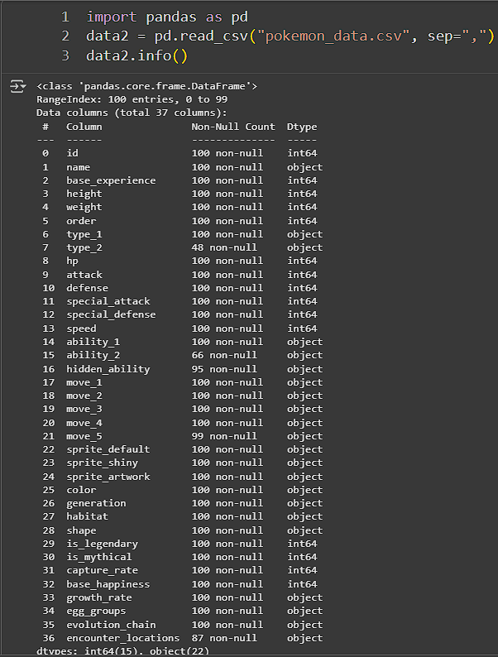

**Рисунок 2 – Многомерные данные**

Листинг 3 – для наборов текста

|  |
| --- |
| import requests  import pandas as pd  import time  from datetime import datetime, timedelta  NEWS_API_KEY = "98a99dffe46c409e81bc6398aff29096"  NEWS_URL = "https://newsapi.org/v2/everything"  CATEGORIES = [  'sports', 'technology', 'health',  'business', 'science', 'politics',  'music', 'environment', 'entertainment',  'ai', 'cybersecurity',  'crypto', 'gaming', 'space', 'fashion',  'travel', 'food', 'books', 'wellness',  'renewables', 'edtech', 'robotics', 'philanthropy'  ]  DOMAINS = {  'sports': 'espn.com,bbc.com/sport',  'technology': 'techcrunch.com,engadget.com',  'health': 'who.int,webmd.com',  'business': 'reuters.com,bloomberg.com',  'science': 'sciencemag.org,nature.com',  'music': 'rollingstone.com, billboard.com, pitchfork.com, nme.com, spin.com',  'politics': 'reuters.com/politics, politico.com, theguardian.com/world',  'environment': 'ipcc.ch, grist.org, carbonbrief.org',  'entertainment': 'variety.com, hollywoodreporter.com',  'ai': 'syncedreview.com, arxiv.org, towardsdatascience.com',  'cybersecurity': 'krebsonsecurity.com, therecord.media, darkreading.com',  'crypto': 'coindesk.com, theblock.co, cointelegraph.com',  'gaming': 'ign.com, polygon.com, eurogamer.net',  'space': 'nasa.gov, spacex.com, skyandtelescope.org',  'fashion': 'vogue.com, wwd.com, businessoffashion.com',  'travel': 'cntraveler.com, lonelyplanet.com, skyradar.com, travelandleisure.com',  'food': 'eater.com, bonappetit.com, foodandwine.com, theinfatuation.com',  'books': 'nytimes.com/books, theguardian.com/books, lrb.co.uk, bookforum.com',  'wellness': 'goop.com, mindbodygreen.com, well.blogs.nytimes.com, tinyhearts.com',  'renewables': 'renewableenergyworld.com, greentechmedia.com, insideclimatenews.org',  'edtech': 'edutopia.org, edsurge.com, timeshighereducation.com/edtech',  'robotics': 'therobotreport.com, ieee.org/spectrum, robohub.org',  'philanthropy': 'ssir.org, philanthropy.com, globalgiving.org'  }  def fetch_news_by_category(category, days=30, limit=50):  from_date = (datetime.now() - timedelta(days=days)).strftime('%Y-%m-%d')  to_date = datetime.now().strftime('%Y-%m-%d')  domain_filter = DOMAINS.get(category, "")  params = {  'q': category,  'from': from_date,  'to': to_date,  'sortBy': 'publishedAt',  'language': 'en',  'pageSize': 100,  'page': 1,  'domains': domain_filter,  'apiKey': NEWS_API_KEY  }  try:  response = requests.get(NEWS_URL, params=params, timeout=15)  response.raise_for_status()  data = response.json()  articles = []  for item in data.get('articles', []):  if len(articles) >= limit:  break  articles.append({  'source_api': 'newsapi.org',  'category': category,  'source_id': item['source']['id'],  'source_name': item['source']['name'],  'author': item.get('author'),  'title': item['title'],  'description': item.get('description'),  'url': item['url'],  'image_url': item.get('urlToImage'),  'published_at': item['publishedAt'],  'content': item.get('content'),  'collected_at': datetime.now().isoformat()  })  print(f"Получено {len(articles)} новостей по теме '{category}'")  return articles  except Exception as e:  print(f"Ошибка при загрузке новостей ({category}): {e}")  return []  print("Сбор текстовых данных (новости)...")  all_articles = []  for category in CATEGORIES:  articles = fetch_news_by_category(category, days=30, limit=30)  all_articles.extend(articles)  time.sleep(1.5)  if all_articles:  df_news = pd.DataFrame(all_articles)  df_news['published_at'] = pd.to_datetime(df_news['published_at'])  df_news.sort_values(by='published_at', ascending=False, inplace=True)  df_news.to_csv('news_data.csv', index=False)  print(f"Сохранено {len(df_news)} новостных записей в textual_news_data.csv") |

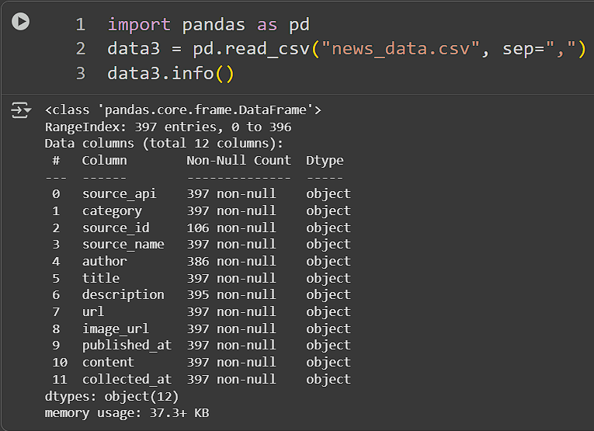

**Рисунок 3 – Набор текста**

1. Сохранение данных в csv.

Результат работы:

Данную работу можете увидеть в блокноте Jupyter Notebook.

<https://drive.google.com/file/d/1o0rhZqLS5oI57PGN8sMn_clyT9e35E8Q/view?usp=sharing>

Вывод:

Научился парсить через API.

Список использованных источников и литературы:

1. Ростовцев В.С. Искусственные нейронные сети,   
   Издательство "Лань", 2019. — 216 с. — URL: https://e.lanbook.com/book/122180
2. Араки М. Манга: Машинное обучение,   
   Издательство "ДМК Пресс", 2020. — 214 с. — URL: <https://e.lanbook.com/book/179473>
3. Платонов, А. В. Машинное обучение : учебное пособие для вузов / А. В. Платонов. — Москва : Издательство Юрайт, 2022. — 85 с. — (Высшее образование). — ISBN 978-5-534-15561-7. — Текст : электронный // Образовательная платформа Юрайт [сайт]. — URL: https://urait.ru/bcode/508804